**Assignment Brief – BTEC**

|  |  |  |  |  |  |
| --- | --- | --- | --- | --- | --- |
| **Programme** | | Level 3 Extended Diploma in Creative Media Production (Games Development) | | | |
| **Unit number(s) and title covered** | | Unit 67: 3D Animation | | | |
| **Assignment number & title** | | Assignment Three: Creating a 3D Animation | | | |
| **Student name** | | *Lewis Hawkins* | | | |
| **Assessor** | | David Matravers | **Internal Verifier** | *James Shaun* | |
| **Date issued** | | 18.03.2019 | **Submission deadline** | 23.05.2019 *at* ***4.30pm*** | |
| **Assessment Criteria** | **To achieve the criteria, the evidence must show that the student is able to:** | | | | **Assessor confirm met** |
| **P3** | Create a 3D animation following industry practice, working within appropriate conventions and with some assistance. | | | |  |
| **M3** | Create a 3D animation to a good technical standard following industry practice, showing some imagination and with only occasional assistance. | | | |  |
| **D3** | Create a 3D animation to a technical quality that reflects near-professional standards following industry practice, showing creativity and flair and working independently to professional expectations. | | | |  |

|  |  |  |  |  |  |  |  |
| --- | --- | --- | --- | --- | --- | --- | --- |
| **Assessor feedback - 1st submission** | | | | | | | |
|  | | | | | | | |
| **Did the learner meet the original deadline or agreed extension?** | | Yes ☐ No ☐ | | | | | |
| **Assessor signature** |  | | | | **Date** | |  |
| **Resubmission authorised?** | | Yes ☐ No ☐ | | | | | |
| **New agreed deadline date for submission** *\* must be within 10 days of receiving original assignment back* | |  | | | | | |
| **Lead Internal Verifier signature** |  | | | **Date** | |  | |
| **Assessor feedback - Resubmission** | | | | | | | |
|  | | | | | | | |
| **Assessor signature** (resubmission only) |  | | **Date** | | | |  |

|  |  |  |  |  |
| --- | --- | --- | --- | --- |
| **Scenario** | | | | |
| Following on from the planning document you produced for “3D Modellers “R” Us” you will now need to take that planning forward to actually produce the fully functional animation.  The animation will need to be between 12 and 15 seconds and needs to be rendered at a resolution of 1280x720; submitted as a .MPEG4 format. | | | | |
| **Tasks and criteria covered** | | | | |
| **Task 1 – P3, M3, D3**  In this task you are required to create your animation. You will need to provide evidence of how you have created the animation itself. Below are a list of topic areas that you will need to provide evidence for. In **bold** are the areas you must cover with the *italics* being topics you may wish to write about.  You will need to ensure you have evidence for all of the following topic areas.   * ***Plan***: asset management (file storage and retrieval, naming conventions); workflow (scheduling, efficient time management); deadlines (production milestones, deliverables, quality assurance)   These are areas you must evidence from your actual animation:   * ***Software interface***: files, eg loading, properties, merging, replacing, importing, saving, backup and autosaving; viewports, eg viewport configuration, viewport controls; workspace, eg command panels, floating palettes and toolbars, drawing aids; animation controls, eg time, trajectories, pivot points, forward kinematics, inverse kinematics, morphing, effects, key frames and playback * ***Animation***: layers; object naming conventions; tools, eg move, stretch, rotate pivot points, linking, kinematics, skeletons, deformations, skin, particle systems, real-world physics * ***Animation techniques***: time-based (animating with key frames); motion control; kinematics (inverse, forward); staging the animation, eg lights, cameras, supports, tripods; biped; deformations; paths/ trajectories; effects, eg motion blur, glow, particle systems, real-world physics; object hierarchies; parentchild inheritance and relationship * ***Animation process***: animating, eg objects, lights, cameras, textures, morphs and transformations * ***Virtual camera***: cameras, eg target, free, camera view; camera parameters, eg lens length, field of vision (FOV), focus, depth of field aperture; camera animation * ***Lighting techniques***: light types, eg ambient, distant, area, spot, point, linear, photometric, raytraced; lighting controls and effects, eg projector, attenuation, colour, shadows; atmospheric, eg clouds, smoke, fire; volumetric, eg fog, mist * ***Texturing techniques***: texturing process, eg creating, loading textures, applying textures; using materials, eg materials editor, mapping materials, material modifiers; material types, eg bitmap, procedural, using avi video files as textures * ***Rendering***: scene rendering, eg rendering controls, rendering options, output size and aspect ratio, safeframe, file type, file size; image resolution, eg TV, film, game, web   For this section you will need to write an evaluation based on the quality of your final animation:   * ***Industry practice***: reflect on finished product (compared with original intentions, fitness for purpose, technical qualities, aesthetic qualities); production skills (ideas generation, animation specification, workflow and time management, technical competence, teamwork) | | | | |
| **Evidence you must produce for this task** | | | | |
| Plan (Gannt Chart etc.)  3D Animation submitted as a .MPEG4 file  Portfolio Document evidencing bold headings from task 1. | | | | |
| **Sources of information** | | | | |
| **Textbooks**  Baylis P, Freedman A, Procter N et al – BTEC Level 3 National Creative Media Production, Student Book  (Pearson, 2010) ISBN 978-1846906725  Baylis P, Freedman A, Procter N et al – BTEC Level 3 National Creative Media Production, Teaching Resource  Pack (Pearson, 2010) ISBN 978-1846907371  Ahearn L – 3D Game Textures: Create Professional Game Art Using Photoshop (Focal Press, 2006)  ISBN 978-0240807683  Birm J – Digital Lighting and Rendering (New Riders, 2006) ISBN 978-0321316318  Brooker D – Essential CG Lighting Techniques with 3Ds Max (Focal Press, 2008) ISBN 978-0240521176  Capizzi T – Inspired 3D Modelling and Texture Mapping (Premier Press, 2002) ISBN 978-1931841504  Gahan A – 3ds Max Modelling for Games: Insider’s Guide to Game Character, Vehicle, and Environment  Modelling (Focal Press, 2008) ISBN 978-0240810614  Summers D – Texturing: Concepts and Techniques (Charles River Media, 2004) ISBN 978-1584503002  **Journals**  3D World  Develop Magazine  Edge Magazine  MCV Magazine  **Websites**  www.3dcafe.com – texture and model resources  www.blinkimage.com – use of environment walk-throughs etc  www.turbosquid.com – textures, models and 3D tutorials | | | | |
| **Student checklist** | | | | **Complete?** |
| Proofread work | | | |  |
| Reference / Bibliography (if applicable) | | | |  |
| All pages attached and numbered – including introduction/conclusion/front sheet | | | |  |
| **Authenticity of Evidence Student declaration** | | | | |
| I certify that the evidence submitted for this assignment is my own.  I have clearly referenced any sources used in the work.  I understand that false declaration of authenticity (i.e. plagiarised work) is a form of academic misconduct and the relevant College procedures will be instigated if I am found to be in contravention of these. | | | | |
| **Student signature** |  | **Date of submission** |  | |
| **Re-authentication of Evidence Student declaration (for resubmission only)** | | | | |
| **Student signature** |  | **Date of resubmission** |  | |

* ***Plan***: asset management (file storage and retrieval, naming conventions); workflow (scheduling, efficient time management); deadlines (production milestones, deliverables, quality assurance)

These are areas you must evidence from your actual animation:

* ***Software interface***: files, eg loading, properties, merging, replacing, importing, saving, backup and autosaving; viewports, eg viewport configuration, viewport controls; workspace, eg command panels, floating palettes and toolbars, drawing aids; animation controls, eg time, trajectories, pivot points, forward kinematics, inverse kinematics, morphing, effects, key frames and playback
* ***Animation***: layers; object naming conventions; tools, eg move, stretch, rotate pivot points, linking, kinematics, skeletons, deformations, skin, particle systems, real-world physics
* ***Animation techniques***: time-based (animating with key frames); motion control; kinematics (inverse, forward); staging the animation, eg lights, cameras, supports, tripods; biped; deformations; paths/ trajectories; effects, eg motion blur, glow, particle systems, real-world physics; object hierarchies; parentchild inheritance and relationship
* ***Animation process***: animating, eg objects, lights, cameras, textures, morphs and transformations
* ***Virtual camera***: cameras, eg target, free, camera view; camera parameters, eg lens length, field of vision (FOV), focus, depth of field aperture; camera animation
* ***Lighting techniques***: light types, eg ambient, distant, area, spot, point, linear, photometric, raytraced; lighting controls and effects, eg projector, attenuation, colour, shadows; atmospheric, eg clouds, smoke, fire; volumetric, eg fog, mist
* ***Texturing techniques***: texturing process, eg creating, loading textures, applying textures; using materials, eg materials editor, mapping materials, material modifiers; material types, eg bitmap, procedural, using avi video files as textures
* ***Rendering***: scene rendering, eg rendering controls, rendering options, output size and aspect ratio, safeframe, file type, file size; image resolution, eg TV, film, game, web

For this section you will need to write an evaluation based on the quality of your final animation:

* ***Industry practice***: reflect on finished product (compared with original intentions, fitness for purpose, technical qualities, aesthetic qualities); production skills (ideas generation, animation specification, workflow and time management, technical competence, teamwork)

**Task One:**

**Plan:**

**Asset Management:**

The assets will be stored in the file structure that follows:

Animation – BlendFiles – AnimationFile

- 3DModels

-Documentation – WordDocs

- Images

**Workflow:**

To manage my time correctly I will create a chart which will display when the plan, concept, animation, etc will be done.

|  |  |  |  |  |  |  |  |  |  |  |
| --- | --- | --- | --- | --- | --- | --- | --- | --- | --- | --- |
|  | 18/03/19 | 25/03/19 | 01/04/19 | 08/03/19 | 15/03/19 | 22/03/19 | 29/03/19 | 06/04/19 | 13/03/19 | 20/03/19 |
| Plan |  |  |  |  |  |  |  |  |  |  |
| Concept |  |  |  |  |  |  |  |  |  |  |
| Models |  |  |  |  |  |  |  |  |  |  |
| Animation |  |  |  |  |  |  |  |  |  |  |
| Lighting |  |  |  |  |  |  |  |  |  |  |
| Effects |  |  |  |  |  |  |  |  |  |  |
| Render |  |  |  |  |  |  |  |  |  |  |

**Software Interface:**

**Files:**

Below is an image displaying how import files into Blender.

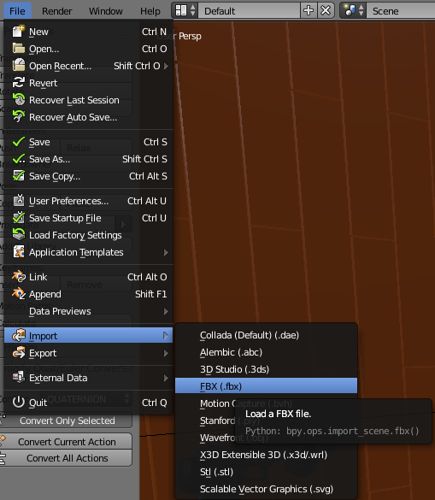

I will also save a backup file for the animation and all 3D models on an external Hardrive.

**Viewports:**

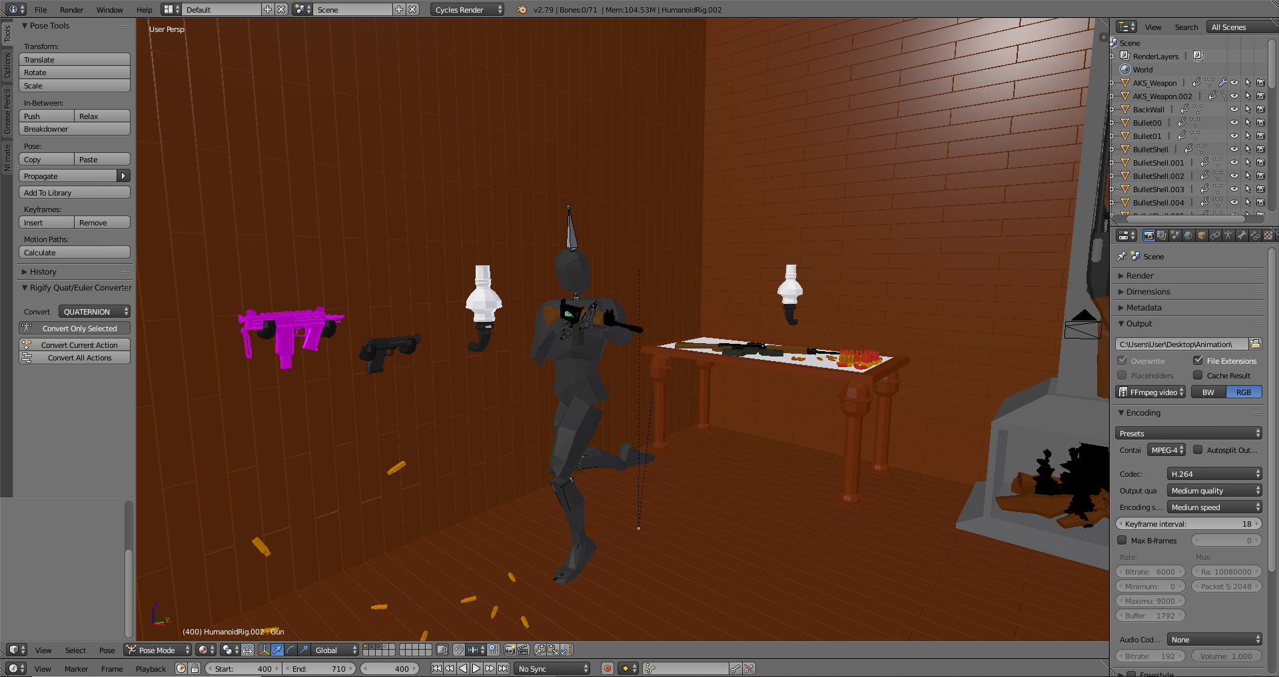

The viewport in Blender is split-up into subsections for the hierarchy, properties menu, animation, scene view, etc. Each viewport can be moved and docked at any location on the screen using creating new windows.

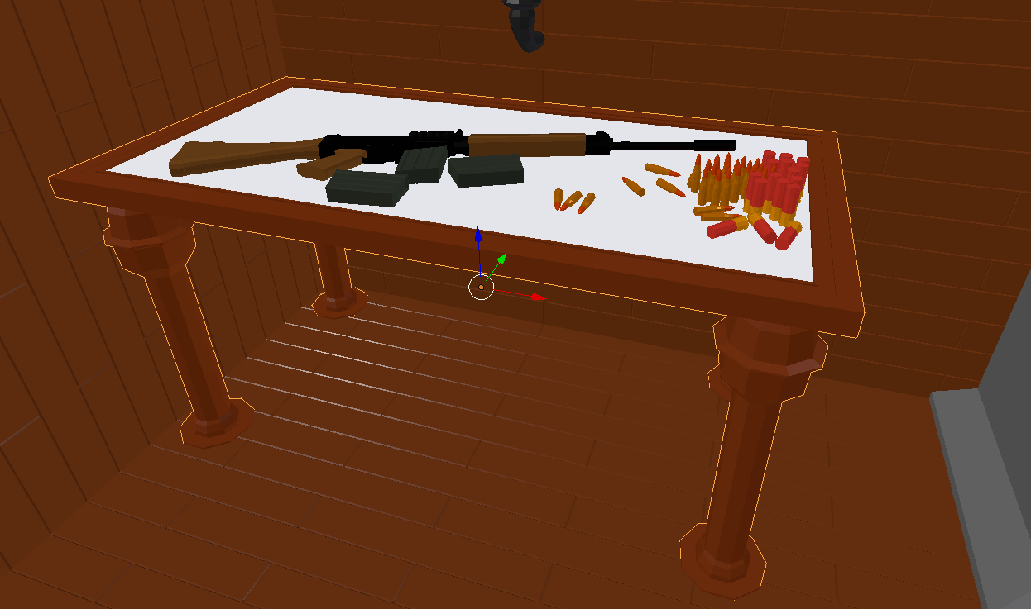

Objects can be moved, rotated and scaled by clicking on them and using the pivot point or keyboard shortcuts (R = rotate, G = move, S = scale).

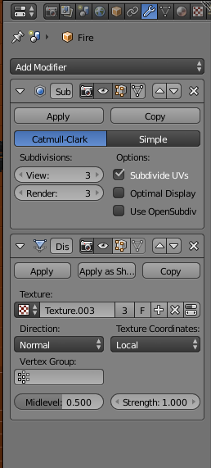

In the properties tab I can add modifiers which improve the modelling and animation workflow. Here I used subdivision surface (Smooths the model by increasing poly count) and displacement (Displaces the vertices using a height map).

**Animation Controls:**

For the skeletal animation I used Inverse Kinematics to improve the speed and accuracy of my work.

The Kinematics are displayed in the image below.

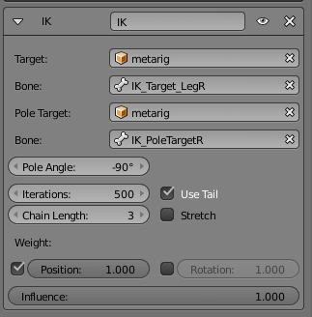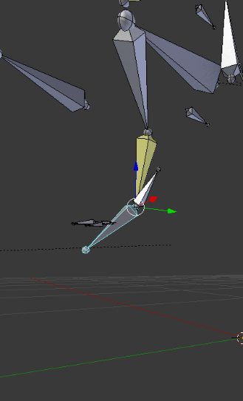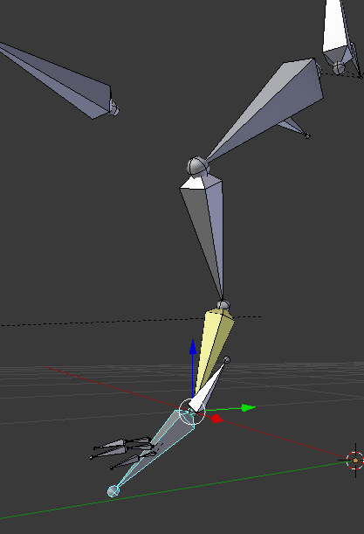

I created Keyframes on the timeline to perform animations.

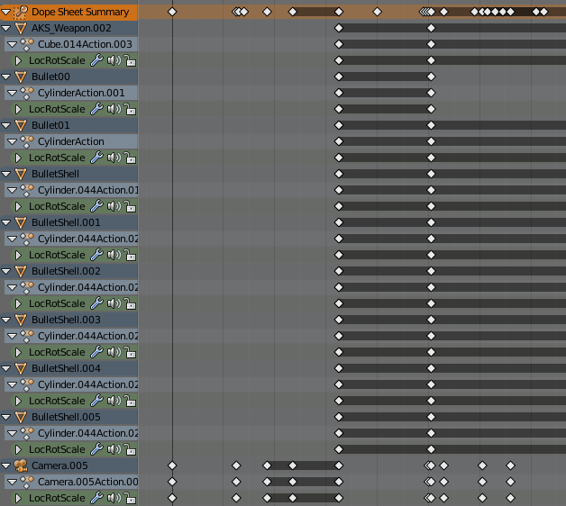

**Animation:**

**Object Naming Conventions:**

Each object in the scene is given a name to help with finding anything quickly:

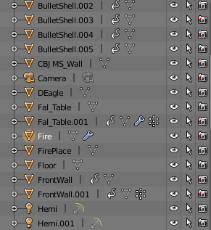

**Tools:**

I used a particle system for the head explosion during the animation:

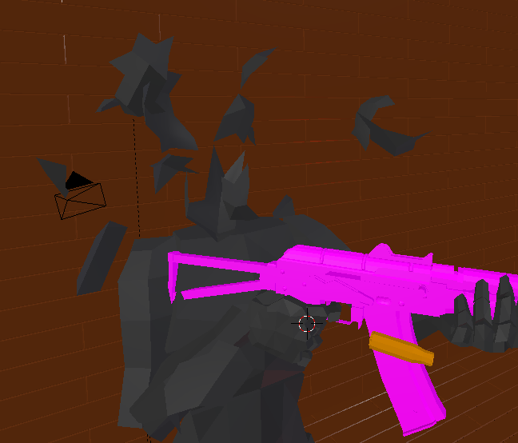

I also used real world physics for the bullet casings, as the fell to the floor. One can be seen in the image above.

I also used skin deformation for the humanoid characters:

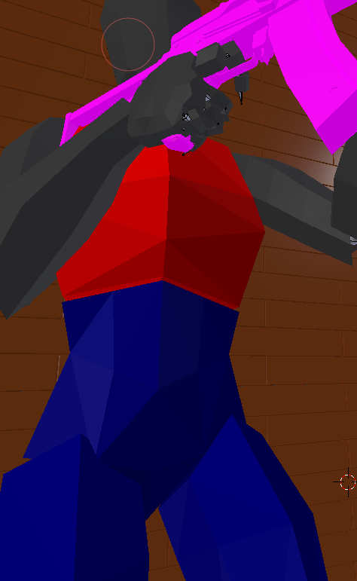Weight:

Red = 100%

Blue = 0%

**Animation Techniques:**

**Time Based:**

The frame rate for the animation is 24FPS which will give me a balance of precise movements and render time.

When keyframing (Image Above) I use auto keyframing, because I speeds up animation and small errors can be corrected in moments.

**Kinematics:**

I used Inverse Kinematics to speed up my animation workflow and to get a more natural look. The kinematics are displayed in the image above, which goes through them in more detail.

**Staging the Animation:**

For lighting I used a mixture of emissive materials and lights. Below is one of the lights I used:

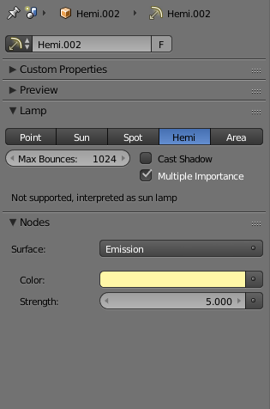

I used the Hemi light because I replicates the indoor lighting far better than any other.

**Animation Process:**

**Animating:**

Each moving object in the scene has a keyframe saving its position on frame 1. This prevents any issues with the object not returning to its origin when the animation restarts.

All the lights in the scene are not animated but the camera is animated to a curve (path) with added rotation to give precise angles.

Below is an image of the path.

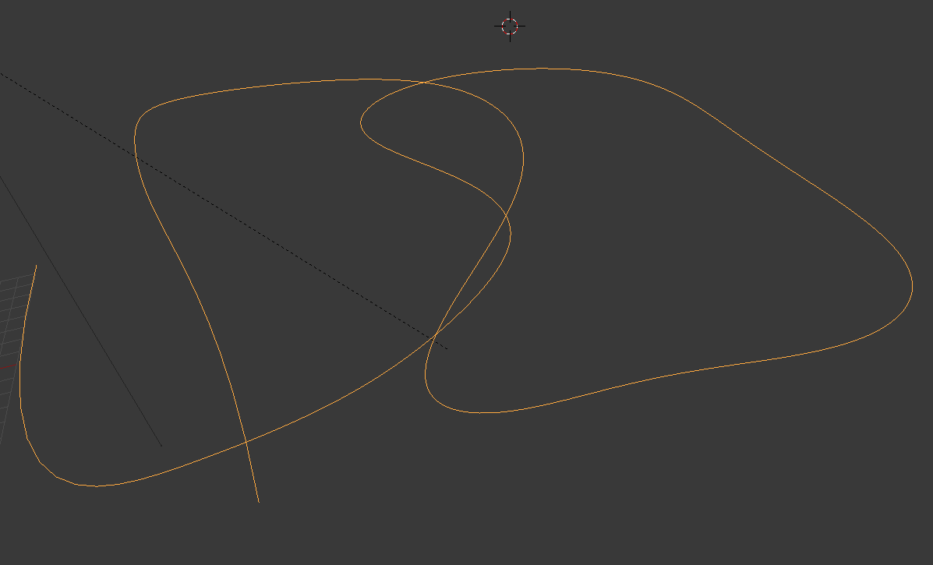

**Virtual Camera:**

**Camera Parameters:**

I modified the camera properties to suit the environment and scene. This is an image of my settings:

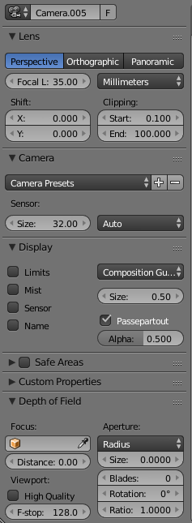

**Camera Animation:**

As displayed in the above section the camera is animated to a path with added rotation.

**Lighting Techniques:**

**Light Types:**

In this animation, I used a mixture of different light sources. A sun light would not be effective since its indoors and there’re no windows, however I did use a Hemi since it performs like a sun but can be placed indoors. Its wide cone of light projectors gives the effect of a sun while also allowing the light to bounce creating an accurate indoor lighting simulation.

I also used emissive materials to light up the walls with a yellow glow, to pair with the lanterns (Showing in the image below).

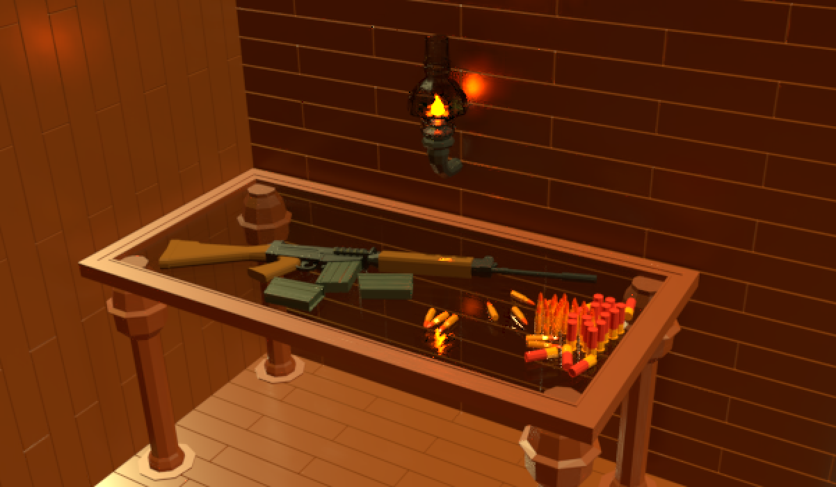

**Lighting Controls:**

I didn’t use any volumetric effects in this animation, but I did change the settings of the lights to give a more realistic effect.

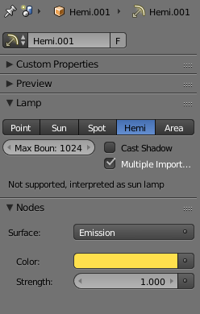

**Texturing Techniques:**

**Texturing Process:**

Unwrapping the model (red = seam):

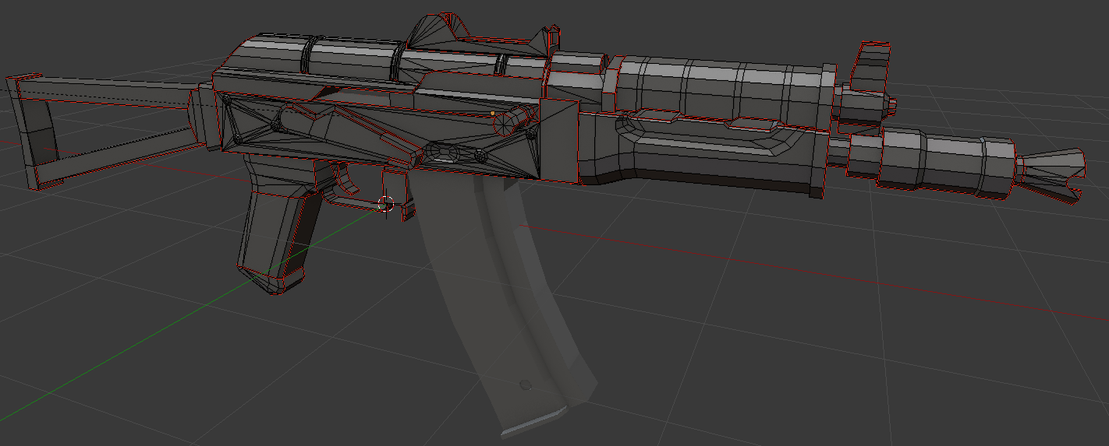

Making the Texture:

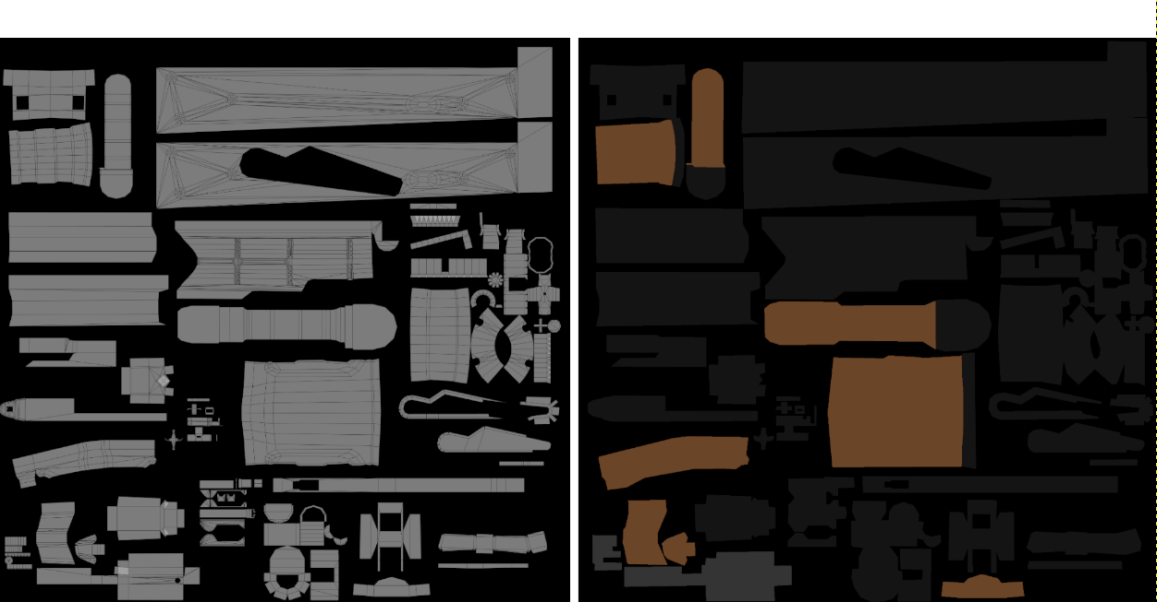

**Using Materials:**

Editing the material:

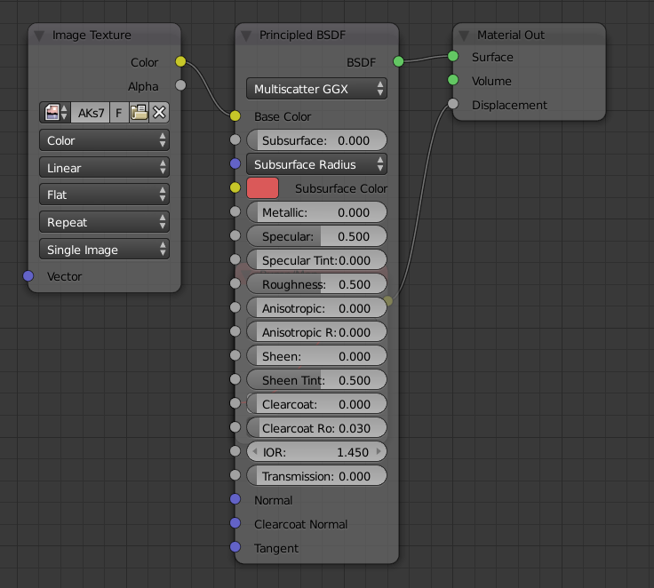

Applying the material:

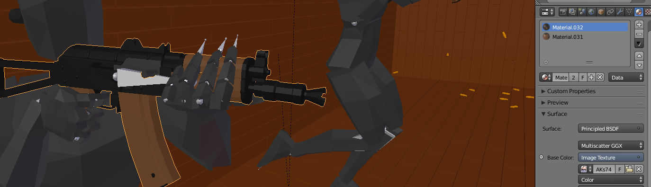

**Rendering:**

**Scene Rendering:**

Below are the settings for the render:

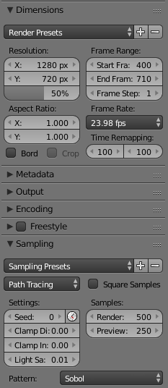

**Image Resolution:**

The resolution was decided by the client and is displayed in the image above.

**Industry Practice:**

**Reflect on Final Product:**

I believe the final product was of very good quality, fitting into all the required categories. The animation itself resembles the planed idea and concept, but to keep to time constraints I had to cut out the explosion at the beginning. This was because the added polygons for the shrapnel and the volumetric smoke simulation caused too many issues with render times.

**Production Skills:**

I felt I was able to concept the idea in a very reasonable time, allowing for me to start on the concept art sooner. I was also able to animate the product in just a few days allowing for more time to be spent on effects and to flush out the final product.